CPE301 – SPRING 2019

Design Assignment 4B

Student Name: Geovanni Portillo

Student #: 8000603824

Student Email: [portig1@unlv.nevada.edu](mailto:portig1@unlv.nevada.edu)

Primary Github address: <https://github.com/portig1/submissions_E>

Directory: submissions_E/DA/LAB4B/

Submit the following for all Labs:

1. In the document, for each task submit the modified or included code (only) with highlights and justifications of the modifications. Also, include the comments.
2. Use the previously create a Github repository with a random name (no CPE/301, Lastname, Firstname). Place all labs under the root folder ESD301/DA, sub-folder named LABXX, with one document and one video link file for each lab, place modified asm/c files named as LabXX-TYY.asm/c.
3. If multiple asm/c files or other libraries are used, create a folder LabXX-TYY and place these files inside the folder.
4. The folder should have a) Word document (see template), b) source code file(s) and other include files, c) text file with youtube video links (see template).

1. **COMPONENTS LIST AND CONNECTION BLOCK DIAGRAM w/ PINS**

Atmel Studio 7

ATmega328PB Xplained mini

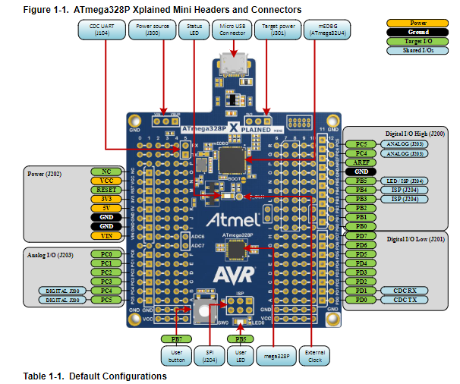

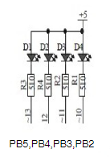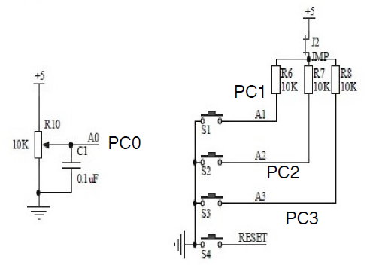

Schematic for shield LEDs (PB5:2) and Potentiometer (PC0)

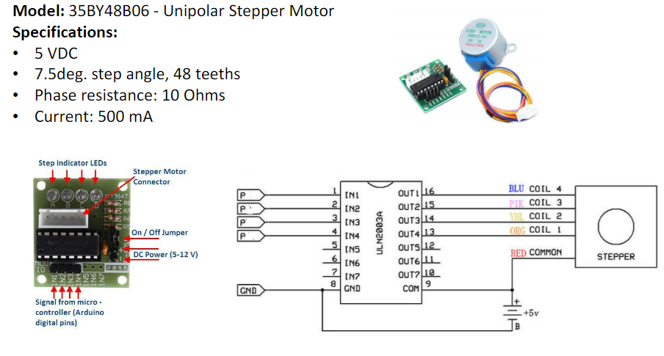

Stepper Motor Diagram

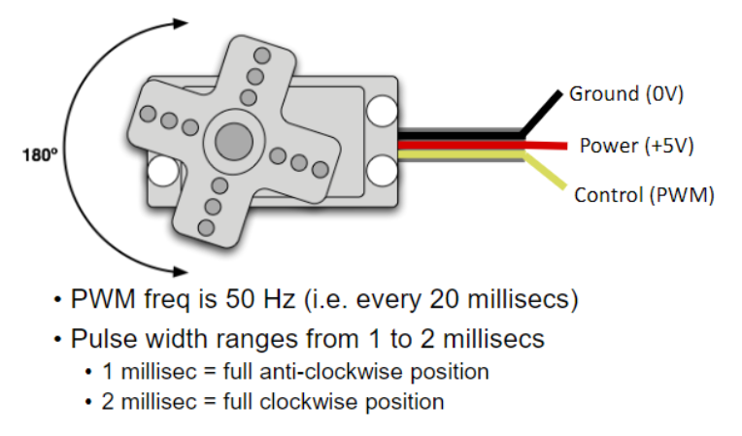

Servo Diagram

1. **INITIAL CODE OF TASK 1**

#define *F_CPU* 16000000UL

#define BAUD_RATE 9600

#define BAUD_PRESCALLER (((*F_CPU* / (BAUD_RATE * 16UL))) - 1)

#include <avr/io.h>

#include <avr/interrupt.h>

#include <stdio.h>

#include <util/delay.h>

void stepperDelay(int delayInMilliseconds);

void usart_init ();

void USART_send(unsigned char data);

void USART_putstring(char* StringPtr);

int main (void)

{

DDRB = 0xFF;

usart_init ();

/** Setup and enable ADC **/

ADMUX = (0<<REFS1)| // Reference Selection Bits

(1<<REFS0)| // AVcc - external cap at AREF

(0<<ADLAR)| // ADC Left Adjust Result

(0<<MUX2)| // Analog Channel Selection Bits

(0<<MUX1)| // ADC0 (PC0) Potentionmeter

(0<<MUX0);

ADCSRA = (1<<ADEN)| // ADC Enable

(0<<ADSC)| // ADC Start Conversion

(0<<ADATE)| // ADC Auto Trigger Enable

(0<<ADIF)| // ADC Interrupt Flag

(0<<ADIE)| // ADC Interrupt Enable

(1<<ADPS2)| // ADC Prescaler Select Bits

(0<<ADPS1)| // CLK/32

(1<<ADPS0);

int delay1 = 20; //20ms delay

int delay2 = 40; //40ms delay

int delay3 = 60;

int delay4 = 80;

int delay5 = 100;

int delay6 = 120;

int delay7 = 140;

int delay8 = 160;

int delay9 = 180;

int delay10 = 200;

while (1)

{

ADCSRA|=(1<<ADSC); //start conversion

while((ADCSRA&(1<<ADIF))==0);//wait for conversion to finish

ADCSRA |= (1<<ADIF);

int tempC = ADCL;

tempC = tempC | (ADCH<<8);

char output[20];

*snprintf*(output, sizeof(output), "%d\r\n", tempC); //prints out potentiometer value to serial terminal

USART_putstring(output);

//When the ADC value from the potentiometer is below 10, a duty cycle of 0% will be output. Then above 10 and below 20, a duty cycle of 10%. This goes on until the value is above

//90 for which only a 95% duty cycle will be produced

if((0 <= tempC) & (tempC < 10))

{

PORTB=0x09;

stepperDelay(delay1);

PORTB=0x08;

stepperDelay(delay1);

PORTB=0x0C;

stepperDelay(delay1);

PORTB=0x04;

stepperDelay(delay1);

PORTB=0x06;

stepperDelay(delay1);

PORTB=0x02;

stepperDelay(delay1);

PORTB=0x03;

stepperDelay(delay1);

PORTB=0x01;

stepperDelay(delay1);

}

else if((10 <= tempC) & (tempC < 20))

{

PORTB=0x09;

stepperDelay(delay2);

PORTB=0x08;

stepperDelay(delay2);

PORTB=0x0C;

stepperDelay(delay2);

PORTB=0x04;

stepperDelay(delay2);

PORTB=0x06;

stepperDelay(delay2);

PORTB=0x02;

stepperDelay(delay2);

PORTB=0x03;

stepperDelay(delay2);

PORTB=0x01;

stepperDelay(delay2);

}

else if((20 <= tempC) & (tempC < 30))

{

PORTB=0x09;

stepperDelay(delay3);

PORTB=0x08;

stepperDelay(delay3);

PORTB=0x0C;

stepperDelay(delay3);

PORTB=0x04;

stepperDelay(delay3);

PORTB=0x06;

stepperDelay(delay3);

PORTB=0x02;

stepperDelay(delay3);

PORTB=0x03;

stepperDelay(delay3);

PORTB=0x01;

stepperDelay(delay3);

}

else if((30 <= tempC) & (tempC < 40))

{

PORTB=0x09;

stepperDelay(delay4);

PORTB=0x08;

stepperDelay(delay4);

PORTB=0x0C;

stepperDelay(delay4);

PORTB=0x04;

stepperDelay(delay4);

PORTB=0x06;

stepperDelay(delay4);

PORTB=0x02;

stepperDelay(delay4);

PORTB=0x03;

stepperDelay(delay4);

PORTB=0x01;

stepperDelay(delay4);

}

else if((40 <= tempC) & (tempC < 50))

{

PORTB=0x09;

stepperDelay(delay5);

PORTB=0x08;

stepperDelay(delay5);

PORTB=0x0C;

stepperDelay(delay5);

PORTB=0x04;

stepperDelay(delay5);

PORTB=0x06;

stepperDelay(delay5);

PORTB=0x02;

stepperDelay(delay5);

PORTB=0x03;

stepperDelay(delay5);

PORTB=0x01;

stepperDelay(delay5);

}

else if((50 <= tempC) & (tempC < 60))

{

PORTB=0x09;

stepperDelay(delay6);

PORTB=0x08;

stepperDelay(delay6);

PORTB=0x0C;

stepperDelay(delay6);

PORTB=0x04;

stepperDelay(delay6);

PORTB=0x06;

stepperDelay(delay6);

PORTB=0x02;

stepperDelay(delay6);

PORTB=0x03;

stepperDelay(delay6);

PORTB=0x01;

stepperDelay(delay6);

}

else if((60 <= tempC) & (tempC < 70))

{

PORTB=0x09;

stepperDelay(delay7);

PORTB=0x08;

stepperDelay(delay7);

PORTB=0x0C;

stepperDelay(delay7);

PORTB=0x04;

stepperDelay(delay7);

PORTB=0x06;

stepperDelay(delay7);

PORTB=0x02;

stepperDelay(delay7);

PORTB=0x03;

stepperDelay(delay7);

PORTB=0x01;

stepperDelay(delay7);

}

else if((70 <= tempC) & (tempC < 80))

{

PORTB=0x09;

stepperDelay(delay8);

PORTB=0x08;

stepperDelay(delay8);

PORTB=0x0C;

stepperDelay(delay8);

PORTB=0x04;

stepperDelay(delay8);

PORTB=0x06;

stepperDelay(delay8);

PORTB=0x02;

stepperDelay(delay8);

PORTB=0x03;

stepperDelay(delay8);

PORTB=0x01;

stepperDelay(delay8);

}

else if((80 <= tempC) & (tempC < 90))

{

PORTB=0x09;

stepperDelay(delay9);

PORTB=0x08;

stepperDelay(delay9);

PORTB=0x0C;

stepperDelay(delay9);

PORTB=0x04;

stepperDelay(delay9);

PORTB=0x06;

stepperDelay(delay9);

PORTB=0x02;

stepperDelay(delay9);

PORTB=0x03;

stepperDelay(delay9);

PORTB=0x01;

stepperDelay(delay9);

}

else

{

PORTB=0x09;

stepperDelay(delay10);

PORTB=0x08;

stepperDelay(delay10);

PORTB=0x0C;

stepperDelay(delay10);

PORTB=0x04;

stepperDelay(delay10);

PORTB=0x06;

stepperDelay(delay10);

PORTB=0x02;

stepperDelay(delay10);

PORTB=0x03;

stepperDelay(delay10);

PORTB=0x01;

stepperDelay(delay10);

}

}

return 0;

}

void usart_init (void)

{

UBRR0H = (*uint8_t*)(BAUD_PRESCALLER >> 8);

UBRR0L = (*uint8_t*)(BAUD_PRESCALLER);

UCSR0B = (1 << RXEN0) | (1 << TXEN0);

UCSR0C = (3 << UCSZ00);

}

void USART_send( unsigned char data) {

while (!(UCSR0A & (1 << UDRE0))); //wait until UDR0 is empty

UDR0 = data; //transmit ch

}

void USART_putstring(char* StringPtr) {

while (*StringPtr != 0x00) {

USART_send(*StringPtr);

StringPtr++;

}

}

void stepperDelay(int delayInMilliseconds)

{

TCNT1 = 0;

OCR1A = (((*F_CPU*/64)/1000)*delayInMilliseconds)-1;

TCCR1B = (1 << WGM12) | (1 << CS11) | (1 << CS10); //CTC mode, CLK/64 for maximum delay of ~260ms

while(TCNT1 < OCR1A); //Wait until TCNT is equal to OCR1A

TCCR1B = 0; //Stop timer

}

1. **INITIAL CODE OF TASK 2**

#define *F_CPU* 16000000UL

#define BAUD_RATE 9600

#define BAUD_PRESCALLER (((*F_CPU* / (BAUD_RATE * 16UL))) - 1)

#include <avr/io.h>

#include <util/delay.h>

#include <stdio.h>

void adc_init();

int adc_read();

void usart_init ();

void USART_send(unsigned char data);

void USART_putstring(char* StringPtr);

int main(void)

{

usart_init();

adc_init();

//Using information from slide 15-16 from Lecture 11 presentation

TCNT1 = 0; // Set timer1 count zero

ICR1 = 39999; // Set TOP count for timer1 in ICR1 register

/* Set Fast PWM, TOP in ICR1, Clear OC1A on compare match, clk/8

F = 2MHz, T = 0.5us

For a period of 20ms, need 20ms/0.5us instructions = 40,000

40,000 instructions per 20ms -> 2 instructions per 1us

*/

TCCR1A = (1<<COM1A1) | (1<<WGM11);

TCCR1B = (1<<WGM13) | (1<<WGM12) | (1<<CS11);

DDRB |= (1 << 1); //OC1A for ATmega328PB = PB1

while(1)

{

//OCR1A will have a range of 1999 to 4999. The 3001HB Servo motor has a maximum travel length listed of approx. 165° from 800us -> 2200us

//Was able to push to 2500us before the motor would stop turning and buzz

OCR1A = 1999 + (adc_read()*2.93) ; //Max adc value is 1023 and 3000/1023 ~= 2.93

}

}

void adc_init() {

/** Setup and enable ADC **/

ADMUX = (0<<REFS1)| // Reference Selection Bits

(1<<REFS0)| // AVcc - external cap at AREF

(0<<ADLAR)| // ADC Left Adjust Result

(0<<MUX2)| // Analog Channel Selection Bits

(0<<MUX1)| // ADC0 (PC0) Potentionmeter

(0<<MUX0);

ADCSRA = (1<<ADEN)| // ADC Enable

(0<<ADSC)| // ADC Start Conversion

(0<<ADATE)| // ADC Auto Trigger Enable

(0<<ADIF)| // ADC Interrupt Flag

(0<<ADIE)| // ADC Interrupt Enable

(1<<ADPS2)| // ADC Prescaler Select Bits

(0<<ADPS1)| // CLK/32

(1<<ADPS0);

}

int adc_read()

{

ADCSRA|=(1<<ADSC); //start conversion

while((ADCSRA&(1<<ADIF))==0);//wait for conversion to finish

ADCSRA |= (1<<ADIF);

int tempADC = ADCL;

tempADC = tempADC | (ADCH<<8);

char output[20];

*snprintf*(output, sizeof(output), "%d\r\n", tempADC); //prints out potentiometer value to serial terminal

USART_putstring(output);

return tempADC;

}

void usart_init (void)

{

UBRR0H = (*uint8_t*)(BAUD_PRESCALLER >> 8);

UBRR0L = (*uint8_t*)(BAUD_PRESCALLER);

UCSR0B = (1 << RXEN0) | (1 << TXEN0);

UCSR0C = (3 << UCSZ00);

}

void USART_send( unsigned char data) {

while (!(UCSR0A & (1 << UDRE0))); //wait until UDR0 is empty

UDR0 = data; //transmit ch

}

void USART_putstring(char* StringPtr) {

while (*StringPtr != 0x00) {

USART_send(*StringPtr);

StringPtr++;

}

}

1. **SCHEMATICS**

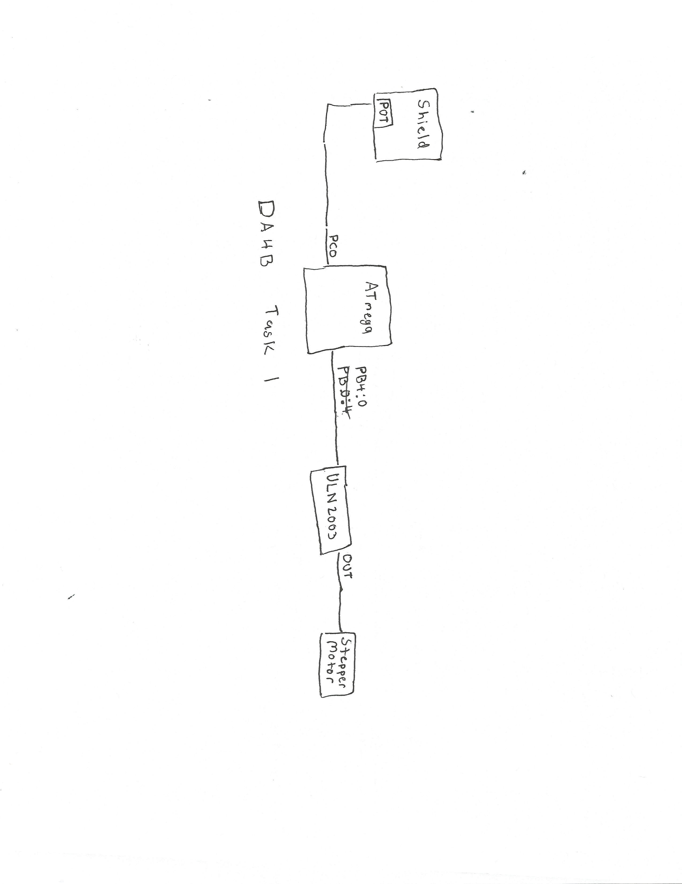

Task 1 Schematic

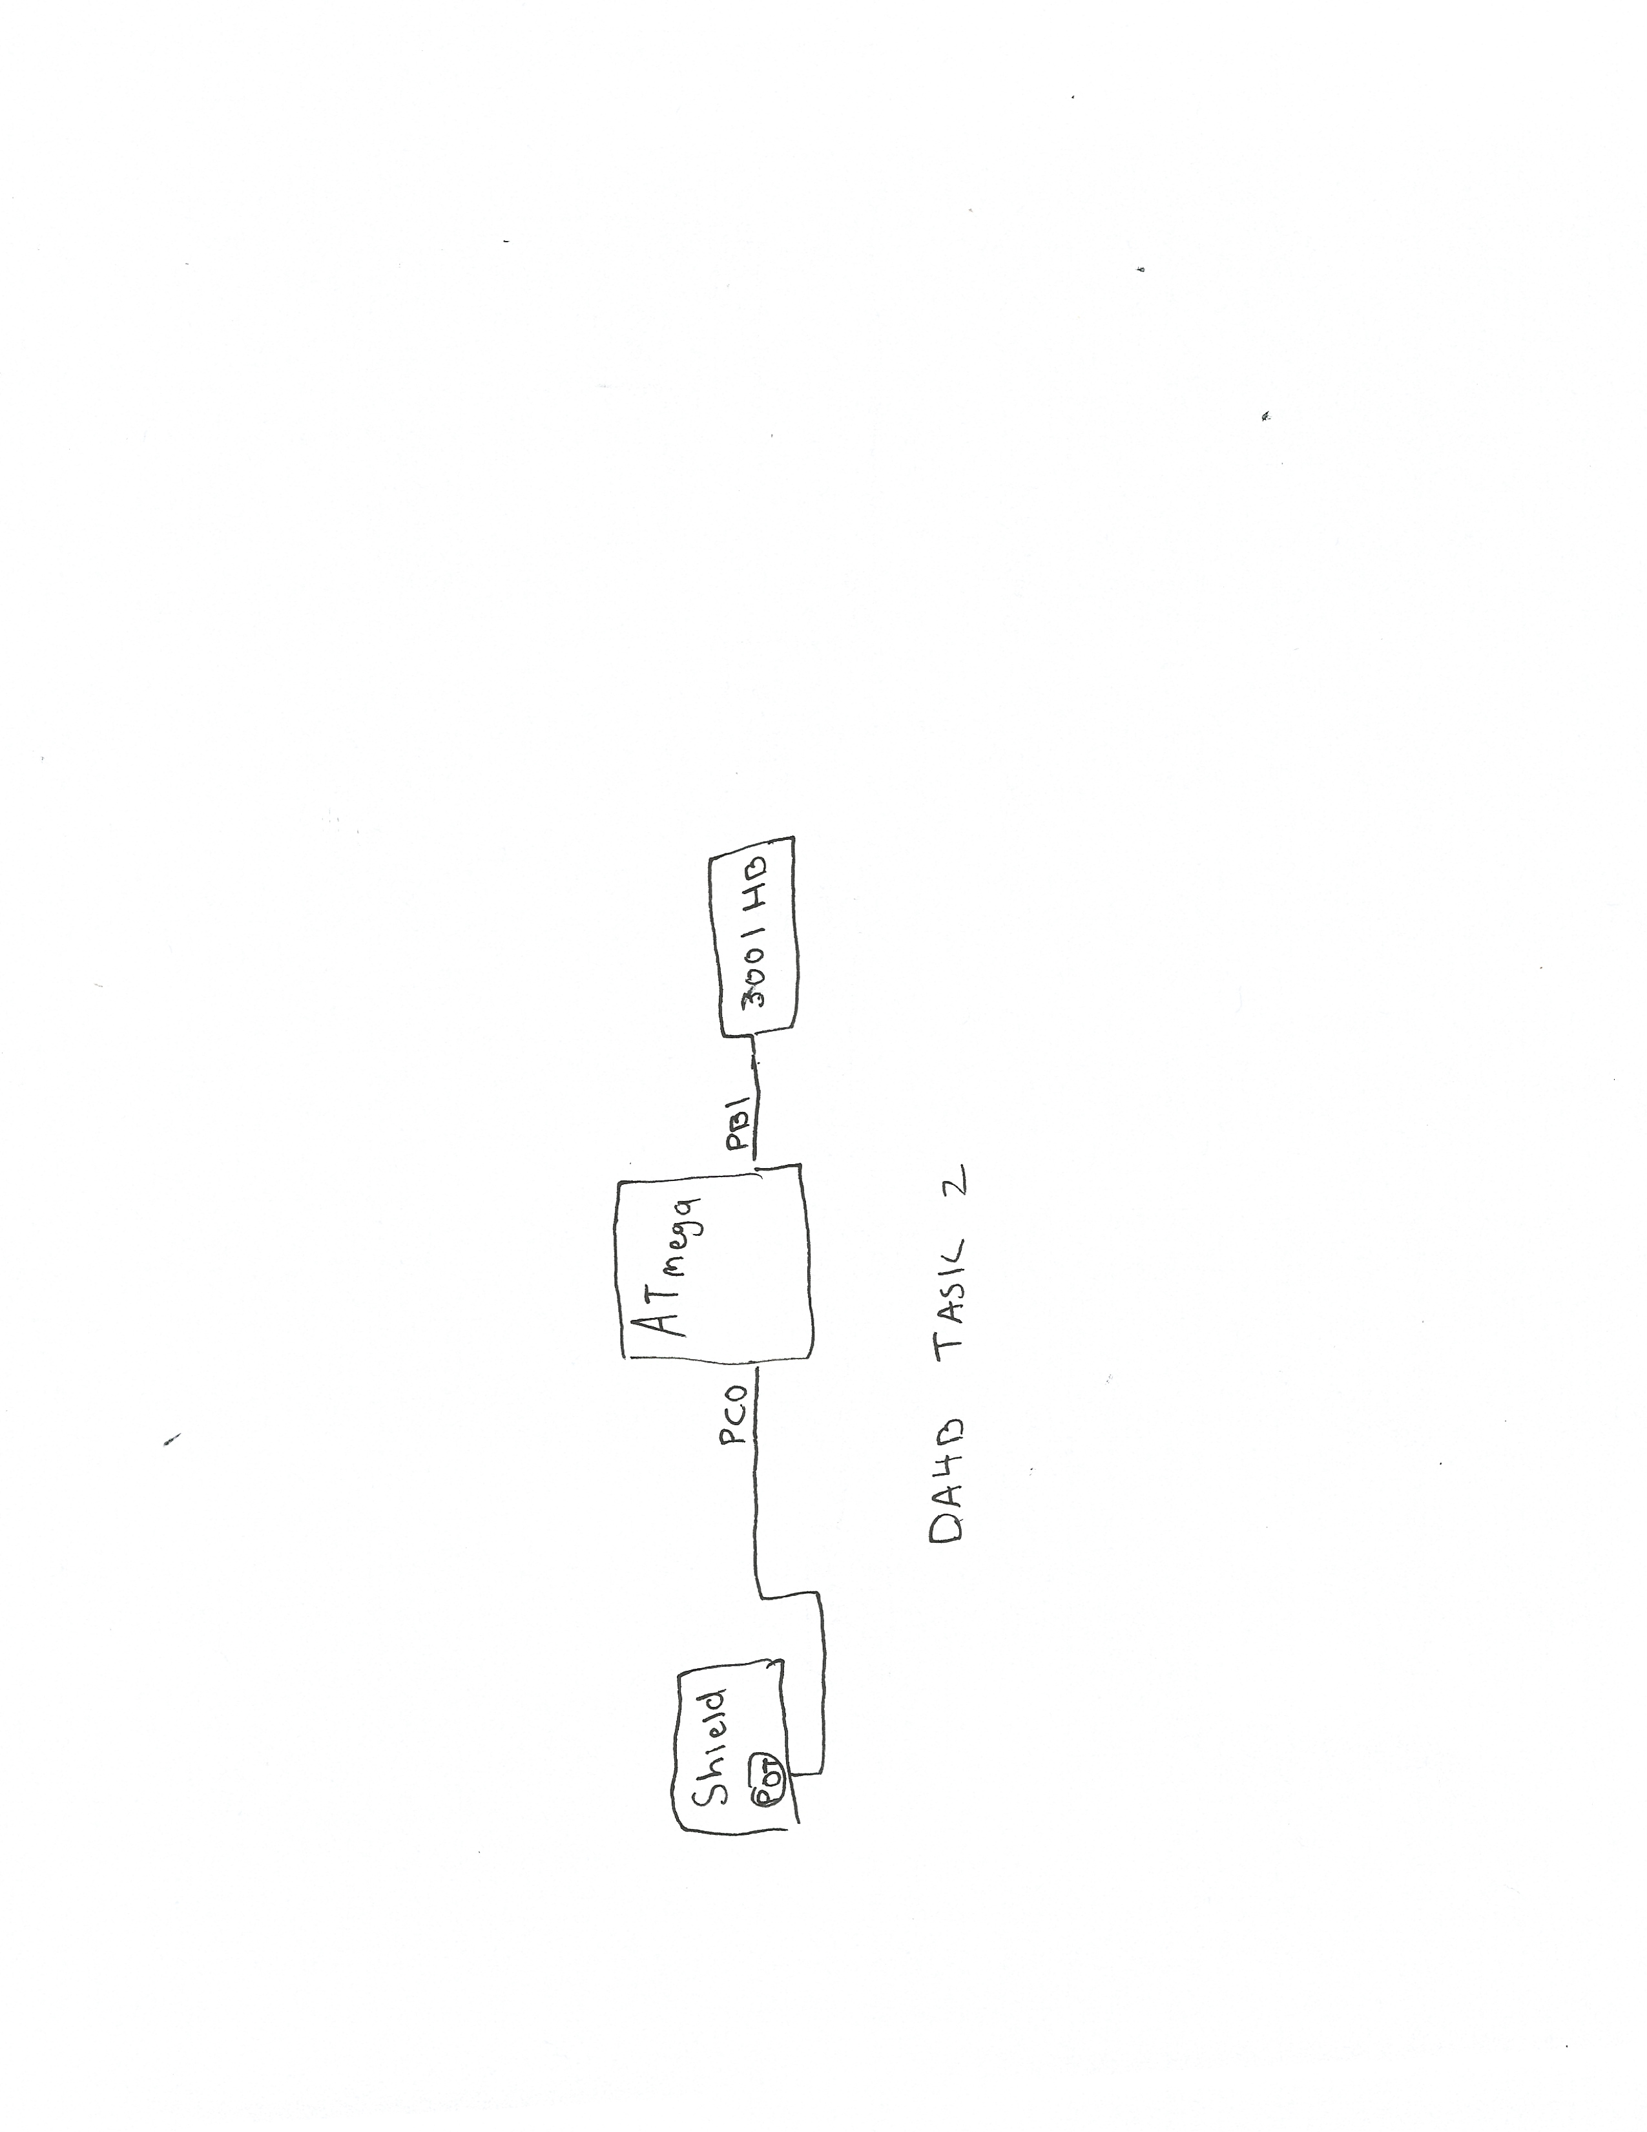

Task 2 Schematic

1. **SCREENSHOTS OF EACH TASK OUTPUT**

Refer to videos to see motor function controlled by potentiometer

1. **SCREENSHOT OF EACH DEMO (BOARD SETUP)**

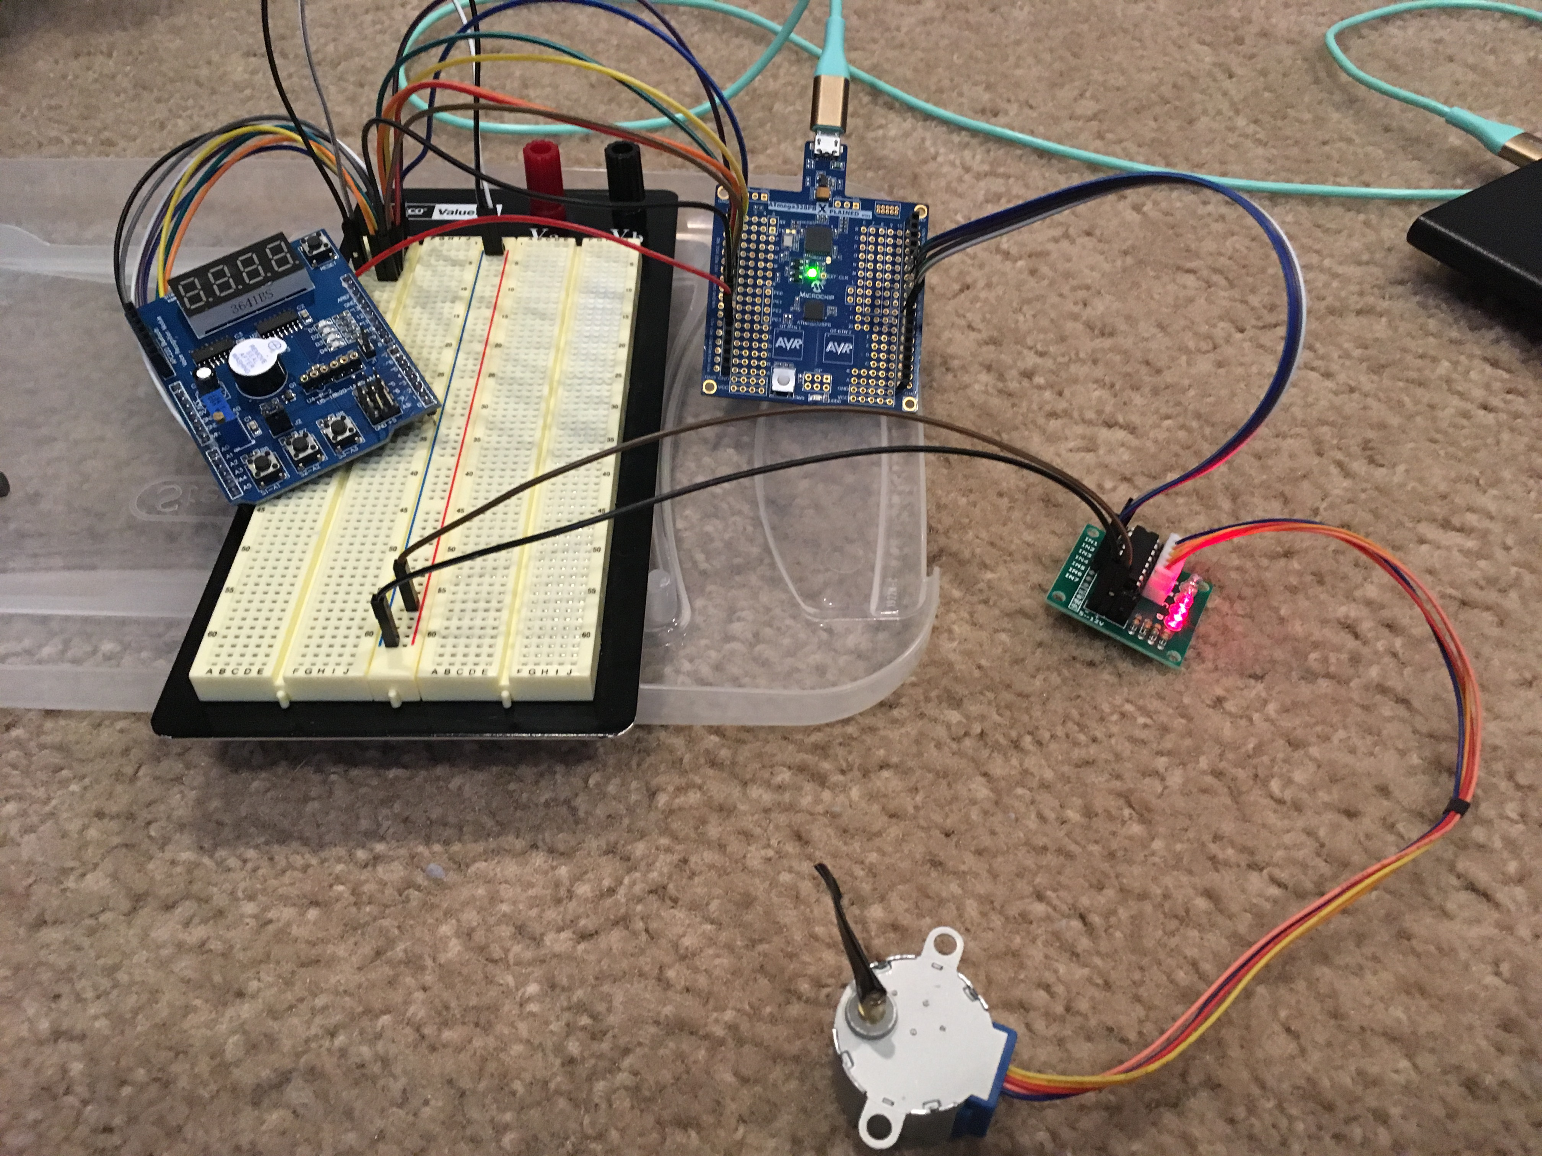

Board setup for Task 1

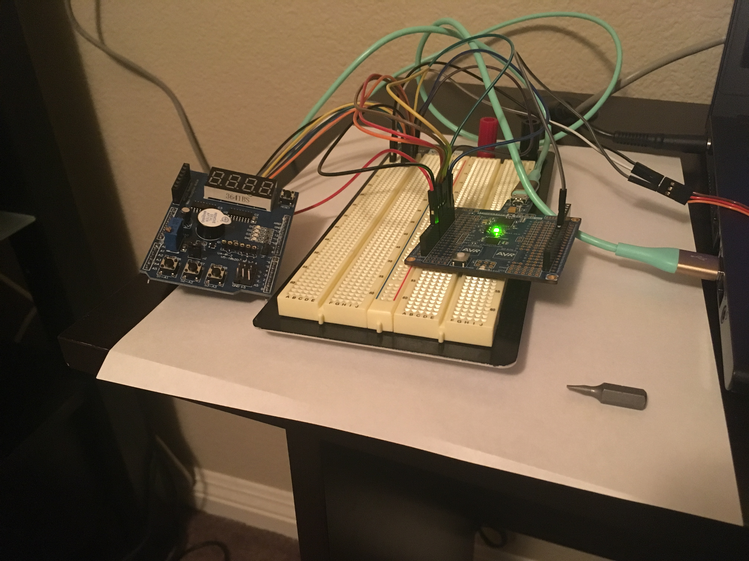

Board setup for Task 2

1. **VIDEO LINKS OF EACH DEMO**

Task1: <https://youtu.be/32tz3yPUxmA>

Task2: <https://youtu.be/ZcZeva9N44o>

1. **GITHUB LINK OF THIS DA**

https://github.com/portig1/submissions_E/tree/master/DA/LAB4B

**Student Academic Misconduct Policy**

<http://studentconduct.unlv.edu/misconduct/policy.html>

“This assignment submission is my own, original work”.

Geovanni Portillo